IS698 Research Summary

Alex Satz

May 14, 2017

This research summary provides a very brief overview of four peer-reviewed research articles that I authored since joining the MSDA program. Each of the research articles contains numerous data science techniques that may be traced back to MSDA course material. For each published paper I provide a brief overview of the scientific question and key result. I also choose to illustrate, technically, how the key result was achieved.

Table of Contents

Primer on DNA encoded libraries. 3

DNA Encoded Library Selections and Insights Provided by Computational Simulations 5

Simulated Screens of DNA Encoded Libraries: The Potential Influence of Chemical Synthesis Fidelity on Interpretation of Structure− Activity Relationships 6

Analysis of the productivity of DNA encoded libraries 7

Analysis of Current DNA Encoded Library Screening Data Indicates Higher False Negative Rates for Numerically Larger Libraries 9

Conclusion 11

Appendix: 12

Title: DELGenerationAndScreening.txt (python script) 12

Title: calculate_xi_ni_from_mi.py 25

Title: determine_total_unique_reads 29

Title: fit_sigmoid.py 32

Title: gen_data_for_sigmoid.py 37

Title: process_seq_data_totalreads.py 40

Title: process_seq_data_uniquereads.py 43

Title: sample_sequencing_data 50

# Primer on DNA encoded libraries.

The journal articles discussed herein contain numerous techniques discussed within the MSDA coursework. However, the techniques are applied within the specific ‘domain’ of DNA encoded libraries. To help those with no domain knowledge, and perhaps little chemistry background, I have written the brief primer below.

What is a DNA encoded library: A DNA encoded library is a mixture of millions of different chemical structures all contained in a small single tube of water. Each chemical structure is identifiable by a DNA oligomer that is covalently attached to it. A miniscule quantity of the library may be taken at any time, and its DNA sequenced, to determine the overall composition of the mixture.

Each unique chemical structure within the library has the potential ability to bind to a biologically relevant protein, and thus become the progenitor of a drug used to teat a human disease. The problem is to figure out which of the millions of chemical structures in the library bind the protein. This problem is solved by i) mixing the library with the protein of interest such that some library members bind to the protein ii) immobilizing the protein on a solid-phase resin iii) washing away non-binding library members and iv) denaturing the protein and collected the bound library members. The composition of the library mixture (now enriched in molecules that bind the protein target) can now be determined via DNA sequencing.

How DNA encoded libraries are made: DNA encoded libraries are constructed stepwise using a methodology termed ‘split-and-pool’. We begin with a large quantity of bi-functional scaffold dissolved in buffer (left side of Figure 1). The scaffold is referred to as bi-functional because one side is undergoes enzymatic ligation to add DNA oligomers, and the other side undergoes chemical reactions to build up a chemical structure.

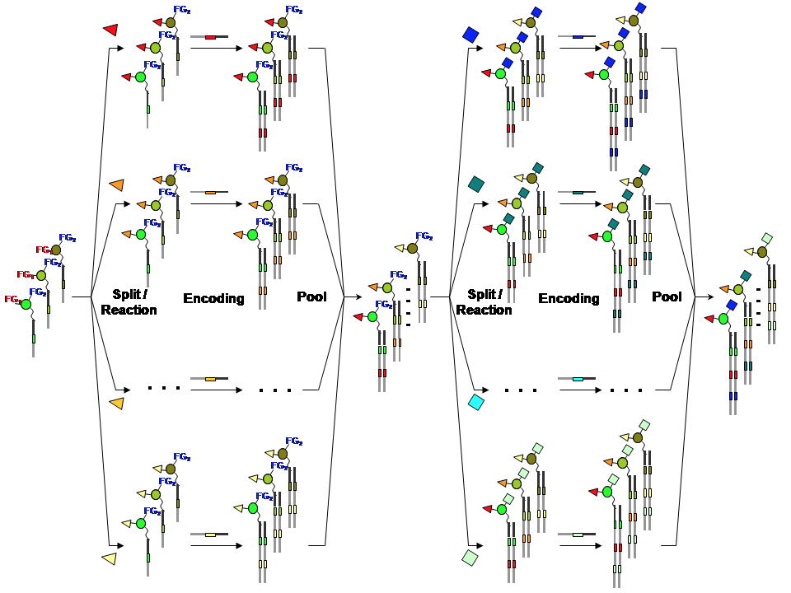

Figure 1. Schematic detailing DNA encoded library synthesis (see <https://en.wikipedia.org/wiki/DNA-encoded_chemical_library>). Starting material is shown on the left-hand side, and finished library on the right-hand side. Starting material is ‘split’ into a number of reaction vessels, and each ‘red’ functional-group (FG) reacted a different chemical building block. The nature of the building block is then encoded by a DNA oligomer ligated onto the other side of the library molecule. The reaction vessels are then ‘pooled’ and re-split, and the process repeated.

# DNA Encoded Library Selections and Insights Provided by Computational Simulations

Alexander L. Satz

DOI: 10.1021/acschembio.5b00378 ACS Chem. Biol. 2015, 10, 2237−2245

Background: DNA encoded libraries are interrogated by high throughput sequencing following a library screen (see primer above). The processed output of the sequencing is that some DNA sequences are ‘observed’ multiple times. Presumably, the more times a library member is observed following a screen, the better it binds the target protein. However, this presumption does not take into account synthetic yields during library production; library members likely possess a large variance in amounts prior to a screen. In this paper I developed a mathematical model describing a DNA encoded library screen. The model may then be used to better understand the limitations of the experimental data.

Result: A closed form mathematical model describing a library screen was derived and used to calculate binding constants from sequencing results. Figure 2 provides the results of a Monte Carlo simulation (allowing for random variables), where a binding constant (for a single library member) is estimated from the derived model.

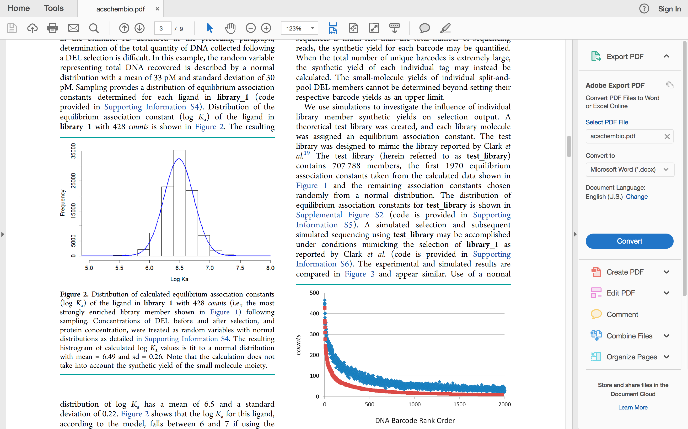

Figure 2. Monte Carlo simulation, and fitting of the calculated value to a normal distribution (note this figure is taken directly from the discussed article).

Techniques: The Monte Carlo simulation was achieved using the random.gauss python function to assign values to random variables. The assigned values were then used to calculate ‘Ka’ (as shown in Figure 2) using the def provided below. This process was repeated hundreds of times, until a stable distribution was observed. The acquired distribution was then fit to a normal distribution using Scipy. Key functions are provided below and are also available from the supporting information of the published article.

The function for converting assigned random variables to a ‘Ka’ value:

*def getKa(B, A, list_conc_final):*

*'''takes floats A, B, and list of library member final concentrations*

*and returns list of calculated association equilibrium constants'''*

*list1 = []*

*for i in list_conc_final:*

*a = (B**3)*i - (B**3)*A*

*b = 3*(B**2)*i*

*c = 3*B*i*

*d = i*

*delta = 18*a*b*c*d - 4*(b**3)*d + (b**2)*c**2 - 4*a*c**3 - 27*(a**2)*(d**2)*

*delta0 = b*b - 3*a*c*

*delta1 = 2*(b**3) - 9*a*b*c + 27*(a**2)*d*

*delta2 = -27*(a**2)*delta*

*u1 = 1*

*u2 = (-1 + 1.0j*(3**(1.0/2)))/2*

*u3 = (-1 - 1.0j*(3**(1.0/2)))/2*

*C = ((delta1 + (delta2**(1.0/2)))/2)**(1.0/3)*

*K1 = (-1/(3*a))*(b + u1*C + delta0/(u1*C))*

*##K2 = (-1/(3*a))*(b + u2*C + delta0/(u2*C))*

*##K3 = (-1/(3*a))*(b + u3*C + delta0/(u3*C))*

*list1.append(K1)*

*return list1*

The function for running the simulation itself:

*read_count = 205 ## sequence reads for a particular library member (ligand)*

*total_reads = 190363 ## total number of usable sequence reads*

*diversity = 7077888.0 ## total number of distinct molecules in the library*

*list_Ka_range = []*

*count = 0*

*while count < 100000:*

*## initial concentration of DEL.*

*del_conc_initial = random.gauss(1.7 * 10**(-5), 0.5*10**(-5))*

*## concentration of active protein*

*protein_conc = random.gauss(0.16*10**(-6), 0.05*10**(-6))*

*## see section S3 for explanation of del_conc_final*

*del_conc_final = random.gauss(33.0* (10**(-12)), 30.0*(10**(-12)))*

*if protein_conc > 0 and del_conc_initial > 0 and del_conc_final > 0:*

*conc_ligand_initial = del_conc_initial/diversity*

*list_conc_final = getConc([read_count], total_reads, del_conc_final)*

*list_Ka = getKa(protein_conc, conc_ligand_initial, list_conc_final)*

*if list_Ka[0] > 0:*

*list_Ka_range.append(list_Ka[0])*

*count += 1*

*outputFile(list_Ka_range, 'sampling_Kvalues.txt')*

# Simulated Screens of DNA Encoded Libraries: The Potential Influence of Chemical Synthesis Fidelity on Interpretation of Structure− Activity Relationships

Alexander L. Satz

DOI: 10.1021/acscombsci.6b00001 ACS Comb. Sci. 2016, 18, 415−424

Background: DNA encoded libraries are interrogated by high throughput sequencing following a library screen (see primer above). The processed output of the sequencing is that some DNA sequences are ‘observed’ multiple times. Presumably, the more times a library member is observed following a screen, the better it binds the target protein. However, this presumption does not take into account synthetic yields during library production; library members do not all exist in the same amounts prior to the screen.

Result: This paper showed how the output of a screen can be strongly affected by variance in yield during library production. I wrote a program (see appendix page 12) that produces in silico DNA encoded libraries and simulates their screening. I was able to show that simulated screens produce complex patterns upon visualization, patterns overall similar to those produced by real experimental screens (Figure 3). However, in the case of the simulated screens, we KNOW that the patterns are strongly influenced by variance in synthetic yields during library production, and not binding strength. For real-world libraries and screens, it is not possible to know the cause of the observed patterns (thus the need for simulations).

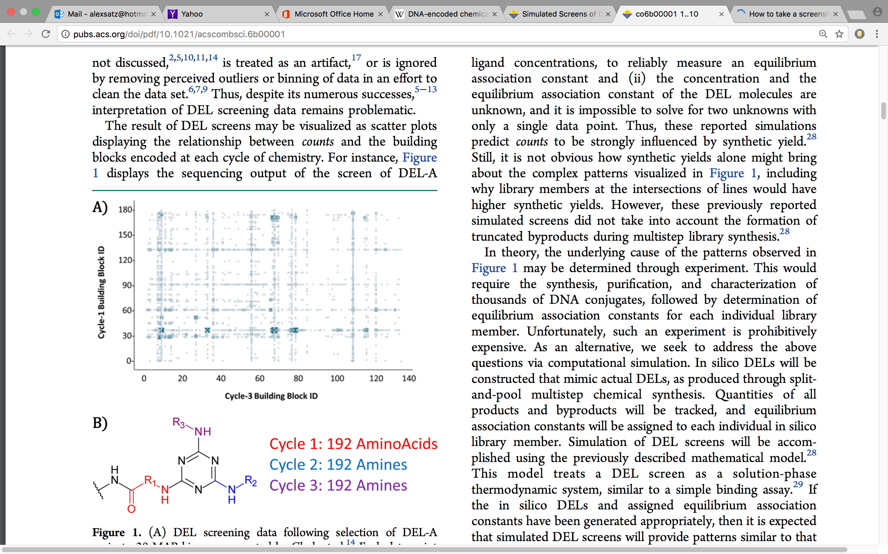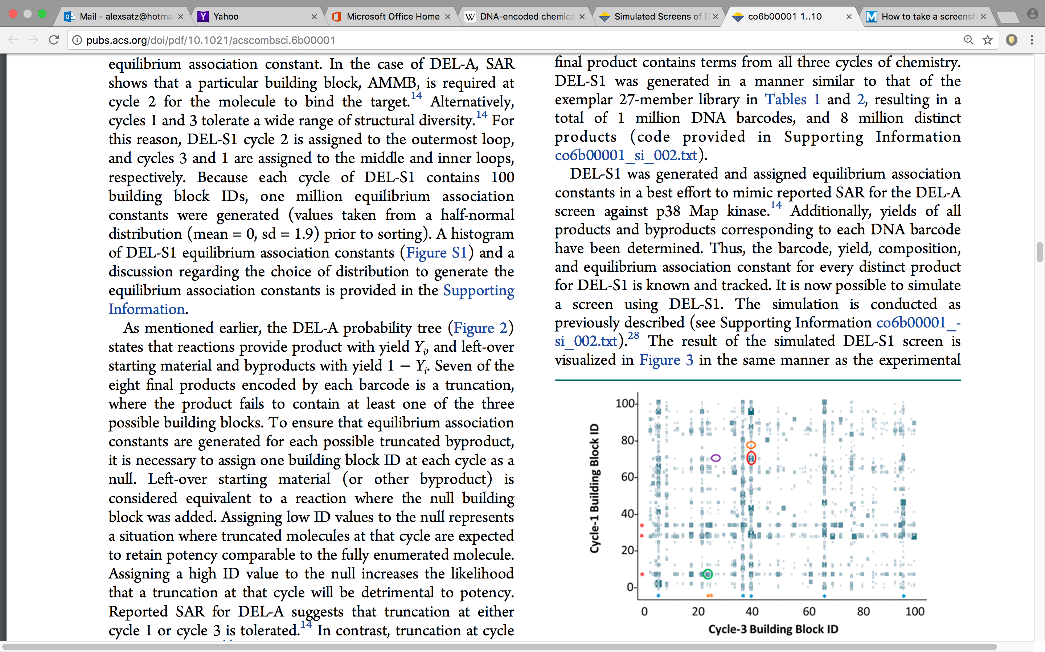

Figure 3. Visualization of an actual library screen (left), versus visualization of a simulated library screen (right); the two visualization possess similar features yet the features of the simulated screen are known to result for variance in synthetic yields (note this figure is taken directly from the discussed article).

Techniques: The creation of an in silico DEL library involved a large amount of tracking, sorting, and deleting rows of a ‘worksheet’. This task was made easier by employing Panda dataframes in python. Three helper functions are taken from the funciton on page 12 of the Appendix to help illustrate. In these functions lists are converted to dataframes, sorted, and select rows deleted. Numerous other uses of the dataframes are illustrated in the Appendix (pages 12-25).

*def convertToDataFrame(listA, listB, listC):*

*'''Takes 3-D list and converts to dataframe'''*

*index1 = numpy.arange(len(listA))*

*newdf = pandas.DataFrame(index = index1)*

*newdf['BBA'] = listA*

*newdf['BBB'] = listB*

*newdf['BBC'] = listC*

*return newdf*

*def sortMol(mol, rlist, x):*

*'''Takes and returns the DataFrame mol'''*

*if x != 0:*

*if rlist[x-1] == rlist[x]:*

*return mol*

*if rlist[x] == 0:*

*return mol.sort_index(by=['BBC', 'BBB', 'BBA'], ascending=[True, True, True])*

*if rlist[x] == 1:*

*return mol.sort_index(by=['BBB', 'BBA', 'BBC'], ascending=[True, True, True])*

*if rlist[x] == 2:*

*return mol.sort_index(by=['BBC', 'BBA', 'BBB'], ascending=[True, True, True])*

*return mol.sort_index(by=['BBB', 'BBC', 'BBA'], ascending=[True, True, True])*

*def deleteCopiedRows(mol, newchunks):*

*'''Takes DataFrame mol and returns DataFrame mol '''*

*for x in newchunks:*

*list1 = x.index*

*for y in list1:*

*try:*

*mol = mol.drop(y)*

*except ValueError:*

*return mol*

# Analysis of the productivity of DNA encoded libraries

Oliv Eidam and Alexander L. Satz

Med. Chem. Commun 2016 016, 7, 1323–1331

Background: A number of molecules were derived from two DNA encoded library screens. In this paper we attempt to use these real-world results to draw some conclusions regarding library size and structural diversity.

Result: Molecules derived from DNA encoded library screens are shown to be unique compared to other screening collections and distinct from each other (Figure 4). Also, the relationship between the physical properties of molecules and the design of libraries from which they are derived is illustrated (Figure 5).

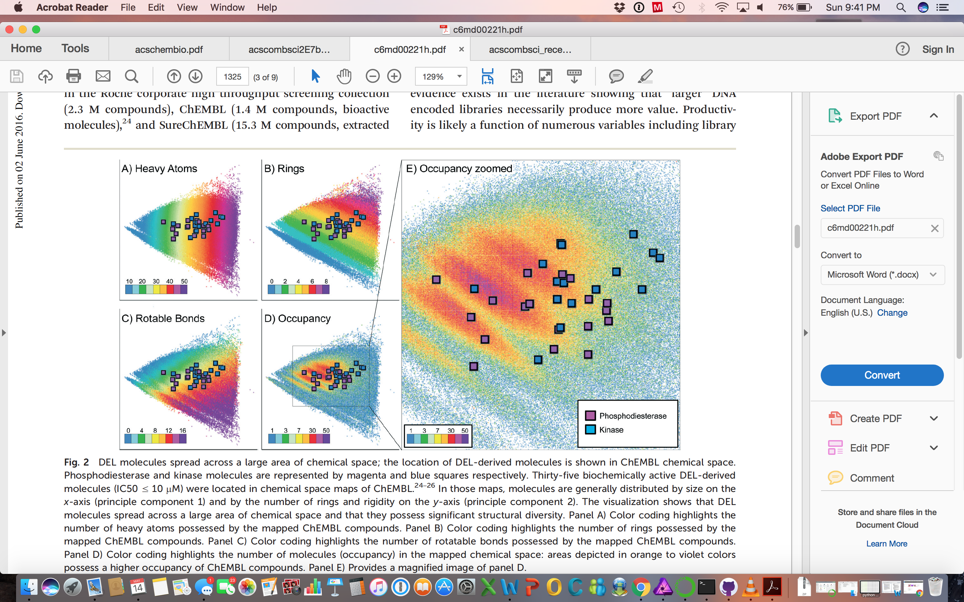

Figure 4. PCA is used to overlay the ‘chemical diversity’ of the DNA encoded library molecules with a known large public collection of chemicals (note this figure is taken directly from the discussed article).

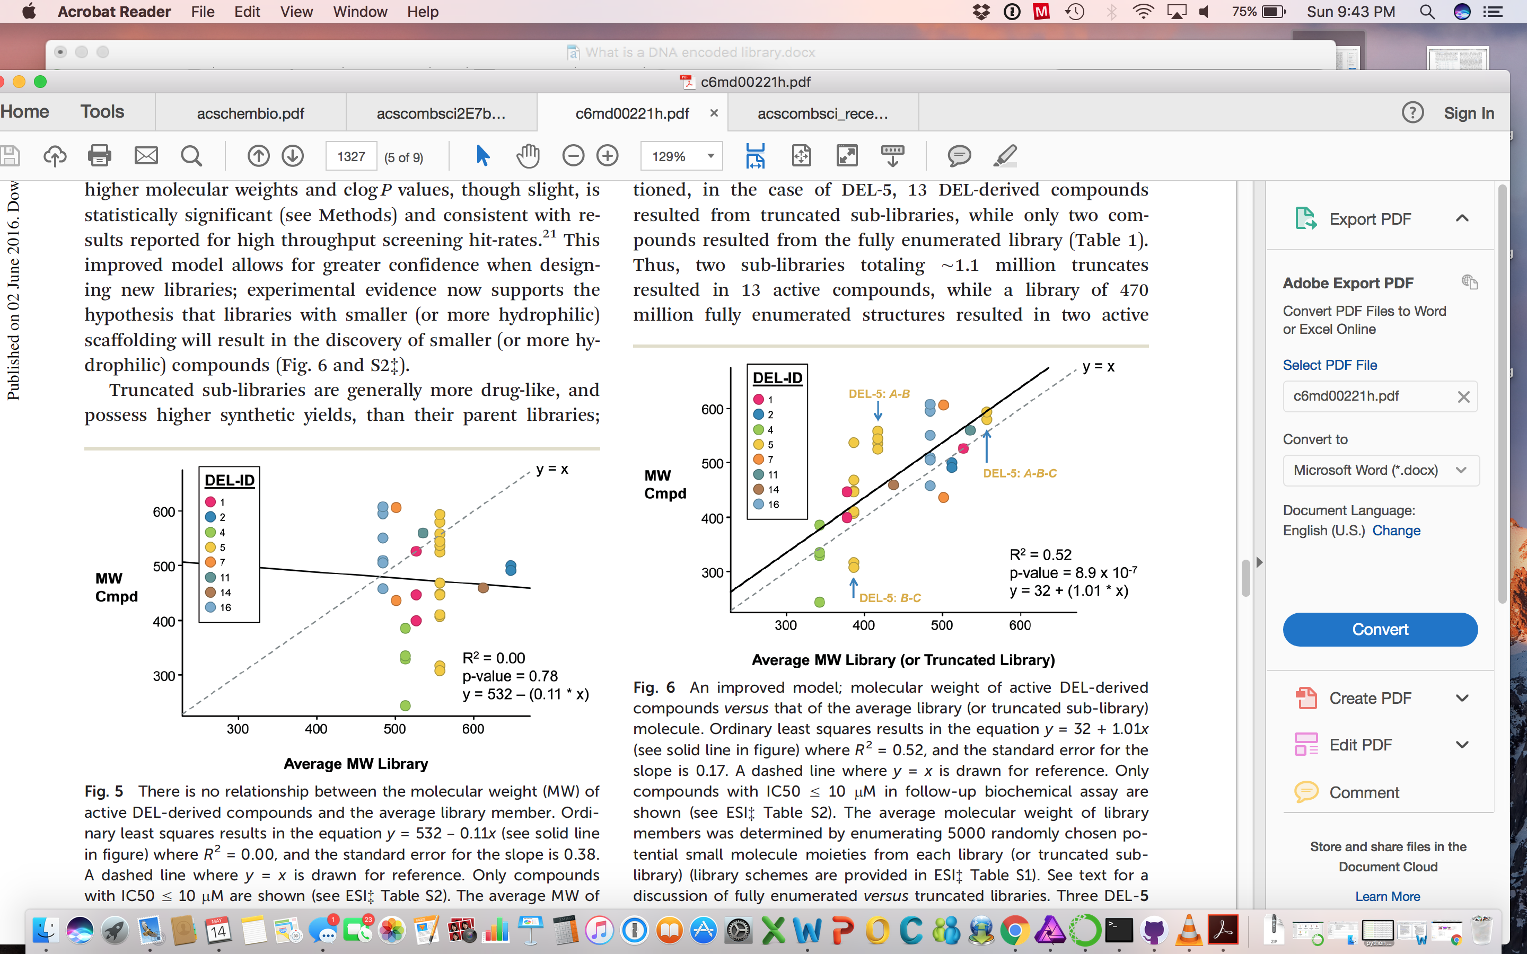

Figure 5. Linear regression is employed to show a relationship between ligand and library physical properties. Monte carlo simulation was also used to demonstrate that the R-squared value of ~0.5 is expected according to the presumed model (note this figure is taken directly from the discussed article).

Techniques: Figure 5 provides OLS of 35 experimental datapoints. The OLS gives a y-intercept of 32. We were interested to determine if this y-intercept value is ‘real’, or a result a too small a sample size such that more samples would converge to an intercept of 0. To futher investigate, five thousand random library members were enumerated for each library, and 35 of these enumerated library members then randomly chosen (from the appropriate libraries). This sampled data set was then fit and the y-intercept determined, and the process repeated until the results stable.

This repeat sampling provided a data set which could be fit to normal distribution with a mean of 0.21 and a SD of 12. Figure 5 shows a y-intercept of 37, ∼3 standard deviations from this mean acquired via sampling (p-value of <.01). Thus we concluded that the null hypothesis was likley not true, and that the shit in the aveage values was probably not due to a lack of experimental data points.

# Analysis of Current DNA Encoded Library Screening Data Indicates Higher False Negative Rates for Numerically Larger Libraries

Alexander L. Satz, Remo Hochstrasser, and Ann C. Petersen

DOI: 10.1021/acscombsci.7b00023 ACS Comb. Sci. 2017, 19, 234−238

Background: An advantage of DNA encoded libraries is the use of split-and-pool synthesis, which allows for the rapid production of extremely large libraries. Indeed, libraries with a chemical diversity of > 1 trillion unique chemical structures may be produced. However, large libraries generally do not produce more ‘value’, despite an expectation that they would. In this paper, we examine an internal data set, augmented with all available external published data, to determine why numerically larger libraries do not produce more.

Results: The library screen strength of ‘signal’ is shown to be inversely proportional to numeric library size; thus larger libraries have weaker signals (Figure 6). Additionally, EQ 1 is provided and derived via numerical analysis. Equation 1 provides a method for calculating the number of unique entities in a sample from the number of duplicate observations via random sampling. Additionally, this article provides python scripts for processing next generation sequencing data to determine n, x, and m values as captured by EQ 1 (see Appendix).

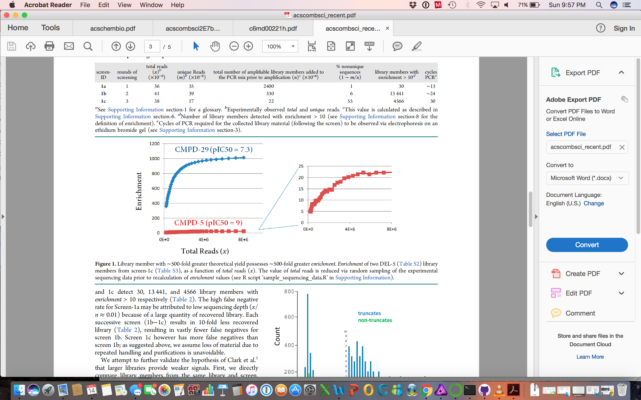

Figure 6. Cmpd-29 (blue) is known to exist in a concentration 500-fold greater than cmpd-5 (red) prior to the screen. After the screen, cmpd-5 is observed via sequencing 500-fold fewer times, despite being a stronger binder. Additionally, the observation of cmpd-5 is highly dependent upon sequencing power is shown via computational sampling (insert) (note this figure is taken directly from the discussed article).

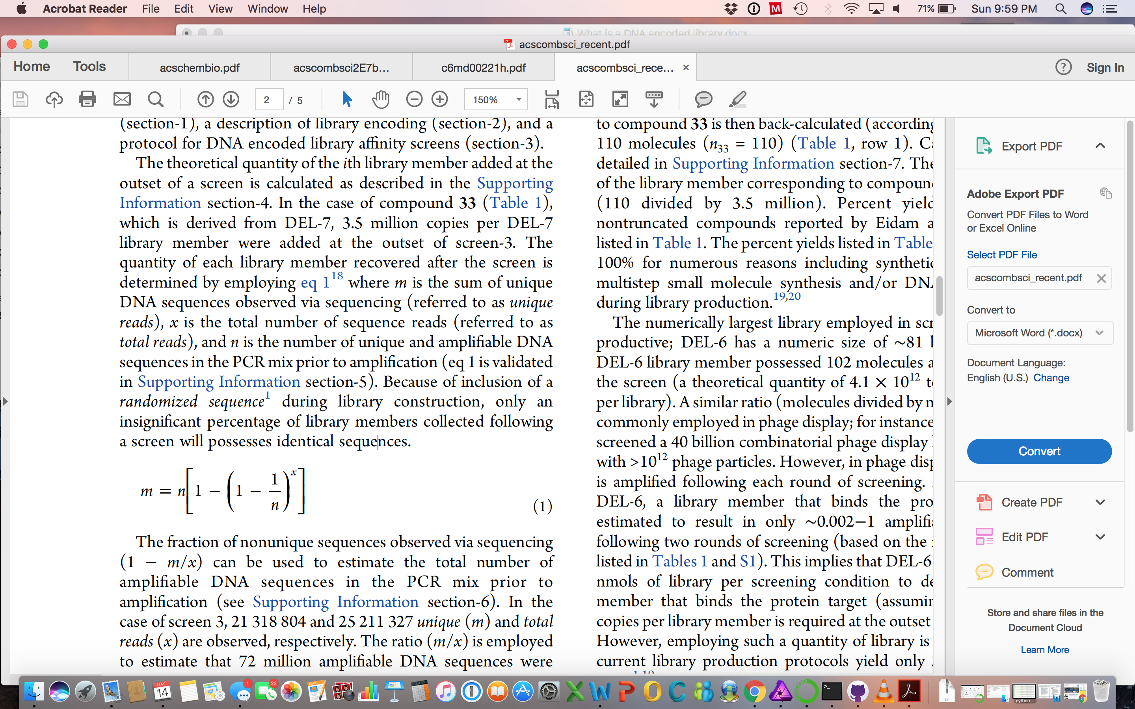

Equation 1. m is the number of unique objects which were observed, x is the total number of observations, n is the number of unique objects. As we require to solve for n, and this solution is non-obvious, we used a a numerical analysis.

Techniques. Equation 1 was discussed on a math exchange website, however a formal derivation was not given. However, with no derivation, how can we prove that the equation is correct? The math behind this equation too difficult for me derive, and so I decided to prove the validity of the equation using numerical analysis.

Equation 1 should provide the same answer as the simulation provided in the short script below. Here we use numpy to sample a uniform distribution and determine the number of times a duplicate value is selected.

*import numpy as np*

*x = 100*

*n = 100*

*l1 = []*

*for i in range(0,100000):*

*a = np.random.randint(n, size=x)*

*a_unique = np.unique(a)*

*m = len(a_unique)*

*l1.append(m)*

*print np.mean(l1)*

I was able to show that any assigned values for *x* and *n* yeilded essentially the same values via EQ1 or the above python script. Of course, the more times the script is run, the closer the calculated value comes to that the closed form equation result.

Additionally, EQ1 above is not readily solved algebraically for *n*, which is the value I wished to calculate from *x* and *m*. And so, I generated a numeric solution based upon a script similar to that provided above and was able to come up with EQs -2 and -3. Essentially, I inputted values of *m* with a fixed *x*, and was able to generate

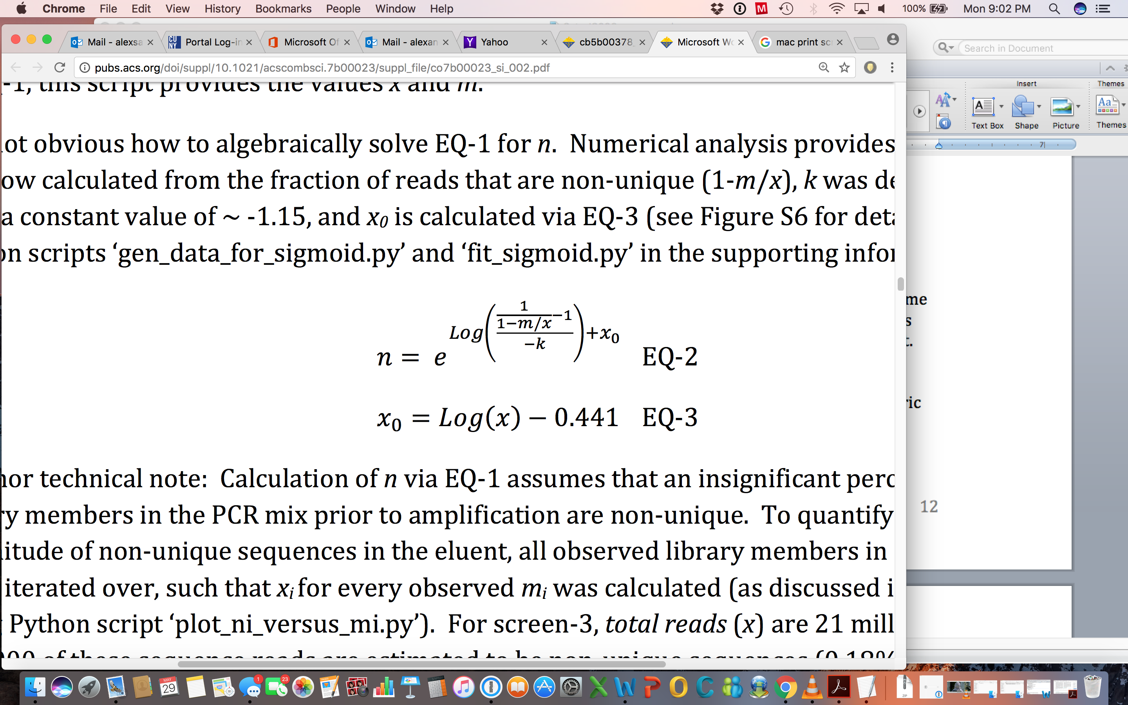

data that could be fit to a sigmoid (EQ-2). The constant *x0* was found to be a constant, and a function of *x*. See the python scripts fit_sigmoid.py and gen_data_for_sigmoid.py in the Appendix (pages 34-35) for details. The results of EQ-3 could then be compared to EQ-1 and found to be equivalent. Thus I was able to effectively solve for n, despite not being able to figure out the algebraic rearrangement.

# Conclusion

Numerous data analysis techniques were employed within the 4 summarized peer-reviewed journal articles. The techniques include programming in both R and python, data visualization, linear regression, PCA, curve fitting, application of random variables, assessment of distributions, error analysis, monte carlo simluations (and other simulations), sampling, and numerical analysis. Largely, the articles discussed herein attempt to generate models to help explain experimental results. The models are used to both make predictions and better understand causality.

# Appendix:

Note that code is taken from the cited articles.

## #Script TITLE: DELGenerationAndScreening.txt (python script)

#Author: Alexander Satz

#Manuscript Title: Simulated Screens of DNA Encoded Libraries; the Potential Influence of Chemical Synthesis Fidelity on Interpretation of Structure-Activity-Relationships

# -*- coding: cp1252 -*-

import random

import time

import datetime

import numpy

import pandas

import copy

#This function partially randomizes the order of BB IDs shown in Table 1 (columns 2-4).

def partialShuffle(mol, sd_a, sd_b, sd_c, lencycA, lencycB, lencycC):

'''Takes a 3-D list of integers and returns a 3-D list of integers with same dimensions'''

for i in range(0, len(mol[0])):

if mol[1][i] != blankB and mol[2][i] != blankC:

posA = i/(lencycB*lencycC)

newpos = abs(int(random.gauss(posA, sd_a)))

if newpos > lencycA-1:

newpos = posA

ia = newpos*lencycC*lencycB

posB = (i-posA*lencycB*lencycC)/lencycC

newpos = abs(int(random.gauss(posB, sd_b)))

if newpos > lencycB-1:

newpos = lencycB-1

ib = newpos*lencycC

posC = i-posA*lencycB*lencycC-posB*lencycC

newpos = abs(int(random.gauss(posC, sd_c)))

if newpos > lencycC-1:

newpos = lencycC-1

ic = newpos

inew = ia+ib+ic

if inew < (lencycA-1)*(lencycB-1)*(lencycC-1):

temp = [mol[0][i], mol[1][i], mol[2][i] ]

test = [mol[0][inew], mol[1][inew], mol[2][inew]]

mol[0][i], mol[1][i], mol[2][i] = mol[0][inew], mol[1][inew], mol[2][inew]

mol[0][inew], mol[1][inew], mol[2][inew] = temp[0], temp[1],temp[2]

return mol

def convertToDataFrame(listA, listB, listC):

'''Takes 3-D list and converts to dataframe'''

index1 = numpy.arange(len(listA))

newdf = pandas.DataFrame(index = index1)

newdf['BBA'] = listA

newdf['BBB'] = listB

newdf['BBC'] = listC

return newdf

def selectDisynthons(startlist, endlist, mol, r):

'''Takes and returns two lists of integers'''

start, end = 1,1

if r == 0:

end = len(mol)

while end > (len(mol) -1):

start = int(lencycB*lencycA*random.randint(0,lencycC) + abs(lencycA*random.randint(0, lencycB-1)))

end = start + lencycA

elif r == 1:

end = len(mol)

while end > (len(mol) -1):

start = int(lencycA*lencycC*random.randint(0,lencycB-1) + abs(lencycC*random.randint(0, lencycA-1)))

end = start + lencycC

elif r == 2:

end = len(mol)

while end > (len(mol) -1):

start = int(lencycA*lencycB*random.randint(0,lencycC-1) + abs(lencycB*random.randint(0, lencycA-1)))

if delA:

start = int(lencycA*lencycB*random.randint(0,lencycC-1))

end = start + lencycB

else:

end = len(mol)

while end > (len(mol) -1):

start = int(lencycA*lencycC*random.randint(0,lencycB-1) + abs(lencycA*random.randint(0, lencycC-1)))

end = start + lencycA

startlist.append(start)

endlist.append(end)

return [startlist, endlist]

def sortMol(mol, rlist, x):

'''Takes and returns the DataFrame mol'''

if x != 0:

if rlist[x-1] == rlist[x]:

return mol

if rlist[x] == 0:

return mol.sort_index(by=['BBC', 'BBB', 'BBA'], ascending=[True, True, True])

if rlist[x] == 1:

return mol.sort_index(by=['BBB', 'BBA', 'BBC'], ascending=[True, True, True])

if rlist[x] == 2:

return mol.sort_index(by=['BBC', 'BBA', 'BBB'], ascending=[True, True, True])

return mol.sort_index(by=['BBB', 'BBC', 'BBA'], ascending=[True, True, True])

def deleteCopiedRows(mol, newchunks):

'''Takes DataFrame mol and returns DataFrame mol '''

for x in newchunks:

list1 = x.index

for y in list1:

try:

mol = mol.drop(y)

except ValueError:

return mol

def removeDisynthons(startlist, endlist, mol, rlistnew):

'''Takes DataFrame mol. Returns DataFrame mol and list of DataFrames newchunks. '''

newchunks = []

for x in range(0, len(startlist)):

mol = sortMol(mol, rlistnew, x)

if startlist[x] != 0:

newchunks.append(mol[startlist[x]:endlist[x]])

else:

newchunks.append(mol[0:endlist[x]])

mol = deleteCopiedRows(mol, newchunks)

random.shuffle(newchunks)

return [mol,newchunks]

def avoidOverlaps(newchunks, listinsert):

'''Returns list of integers'''

for x in range(1, len(listinsert)):

if listinsert[x] < listinsert[x-1] + len(newchunks[x-1]):

listinsert[x] = 1 + listinsert[x-1] + len(newchunks[x-1])

return listinsert

def chooseInsertionPoints(newchunks):

'''Takes of DataFrames and returns a list of integers'''

listinsert = []

for x in range(0, len(newchunks)):

r = random.randint(0,3000)

listinsert.append(r)

listinsert.sort()

return avoidOverlaps(newchunks, listinsert)

def reinsertDisynthons(listinsert, mol, newchunks):

'''Takes and returns dataframe mol'''

for x in range (0,len(newchunks)):

start = listinsert[x]

mol1 = mol[0:start]

mol2 = mol[start:]

f = [mol1,newchunks[x], mol2]

mol = pandas.concat(f)

mol = mol.drop_duplicates()

return mol

#Creates cycle-1,3; 2,3; 3,2; and 3,1 combinations which bind the in silico target.

#This results in lines in all three planes of a visualized 3-D cube.

#The function returns a DataFrame which represents the

#library, with a result similar to that shown in Table 1, columns 1-4.

#See supporting information for an overview of the algorithm.

def createDisynthonClusters(mol, number, delA):

'''Takes and Returns DataFrame'''

if number == 0:

return mol

startlist = []

endlist = []

rlist = []

for x in range (0,number):

if delA:

rlist.append(2)

else:

rlist.append(random.randint(0,3))

rlist.sort()

for x in range (0,number):

startlist, endlist = selectDisynthons(startlist, endlist, mol, rlist[x])

mol, newchunks = removeDisynthons(startlist, endlist, mol, rlist)

mol = mol.sort_index(by=['BBA', 'BBB', 'BBC'], ascending=[True, True, True])

listinsert = chooseInsertionPoints(newchunks)

mol = reinsertDisynthons(listinsert, mol, newchunks)

mol = mol.reset_index(drop=True)

return mol

def convertToLists(mol):

'''convert dataframe to 3-D list'''

listA = mol['BBA']

listB = mol['BBB']

listC = mol['BBC']

return [listA, listB, listC]

#Generates the library, with a result similar to that shown in Table 1, columns 1-4. Returns a 3-D list.

#The first list represents BB IDs of the outer loop, the second the middle loop, and the third list the inner loop.

def generateInSilicoDEL(lencycA, lencycB, lencycC, num_clusters, sd_a, sd_b, sd_c, delA, shuffle, randomizeCycleB):

'''Returns a 3-D list of integers. Each list has length equal to the product of lencycA*lencycB*lencycC'''

mol = [[None]*lencycA*lencycB*lencycC, [None]*lencycA*lencycB*lencycC,[None]*lencycA*lencycB*lencycC]

count = 0

for w in range(0,lencycA): #Outer loop, see Table 1 in manuscript

for x in range(0,lencycB): #Middle loop

for y in range(0,lencycC): #Inner loop

mol[0][count] = w

mol[1][count] = x

mol[2][count] = y

count += 1

if randomizeCycleB:

mol = randomizeCycleBandC(lencycB, lencycC, mol)

mol = convertToDataFrame(mol[0],mol[1],mol[2])

mol = createDisynthonClusters(mol, num_clusters, delA)

mol = convertToLists(mol)

if shuffle:

mol = partialShuffle(mol, sd_a, sd_b, sd_c, lencycA, lencycB, lencycC)

return mol

def genKlist(lencycA, lencycB, lencycC, sd = 1.75):

'''generates sorted list of Log10(Ka) values'''

Klist = []

for x in range(0,lencycA*lencycB*lencycC):

Klist.append(abs(random.gauss(0, sd)))

Klist.sort(reverse = True)

return Klist

#Every building block has 2 assigned yields. In the case of an FMOC amino acid, one yield represents

#acylation onto the DNA-conjugate, and the second yield represents the product of FMOC removal

#and acylation with an incoming reagent. Yields are randomly sampled from a normal distribution.

def genYields(blankA,blankB,blankC, truncationsZeroYields, lencycA, lencycB, lencycC,avgyield,sdyield ):

'''Returns lists of dictionaries. Keys are BB IDs, values are yields'''

listYields1 = [{},{},{}]

listYields2 = [{},{},{}]

cycA, cycB, cycC = {}, {}, {}

blanks = [blankA,blankB,blankC]

numbers = [lencycA, lencycB, lencycC]

for d in range (0, 3):

for x in range(0,numbers[d]):

num = str(x)

value = random.gauss(avgyield,sdyield)

if value >100:

value = 100

if value <1:

value = 1

listYields1[d][num] = value/100.0

for d in range (0, 3):

for x in range(0,numbers[d]):

num = str(x)

value = random.gauss(avgyield,sdyield)

if value >100:

value = 100

if value <1:

value = 1

if truncationsZeroYields:

if x == blanks[d]:

value = 1

listYields2[d][num] = value/100.0

return [listYields1, listYields2]

def calcConcentrations1stCycle(listYields1,listYields2, blankA, blankB, blankC, delA):

'''Takes a 3-D list and returns a 5-D list'''

yield_list1 = []

for x in range(0, len(mol[0])):

y_1 = listYields1[0][str(mol[0][x])] ## incoming BB

yield_list1.append([mol[0][x],mol[1][x],mol[2][x], y_1, mol[0][x]])

yield_list1.append([mol[0][x],mol[1][x],mol[2][x], 1-y_1, blankA])

return yield_list1

def calcConcentrations2ndCycle(yield_list1, listYields1,listYields2, blankA, blankB, blankC, delA):

'''Takes a 5-D list and returns a 6-D list'''

yield_list2 = []

for x in range(0, len(yield_list1)):

y_1 = listYields1[1][str(yield_list1[x][1])] ## incoming BB

y_2 = listYields2[0][str(yield_list1[x][4])] ##DNA conjugated BB

y = min(y_1,y_2)

if delA:

y = y_1

yield_list2.append([yield_list1[x][0],yield_list1[x][1],yield_list1[x][2], yield_list1[x][3]*y, yield_list1[x][4], yield_list1[x][1]])

yield_list2.append([yield_list1[x][0],yield_list1[x][1],yield_list1[x][2], yield_list1[x][3]*(1-y), yield_list1[x][4], blankB])

return yield_list2

def calcConcentrations3rdCycle(yield_list2, listYields1,listYields2, blankA, blankB, blankC, delA ):

'''Takes a 6-D list and returns a 7-D list'''

yield_list3 = []

for x in range(0, len(yield_list2)):

y_1 = listYields1[2][str(yield_list2[x][2])] ##incoming BB

y_2 = listYields2[1][str(yield_list2[x][5])]

y = min(y_1,y_2)

if delA:

y_2 = listYields2[2][str(yield_list2[x][2])] ##incoming BB, second reaction yield

yield_list3.append([yield_list2[x][0],yield_list2[x][1],yield_list2[x][2], yield_list2[x][3]*y_1*y_2, yield_list2[x][4], yield_list2[x][5], yield_list2[x][2]]) ##forms product

yield_list3.append([yield_list2[x][0],yield_list2[x][1],yield_list2[x][2], yield_list2[x][3]*y_1*(1-y_2), blankA, blankB, yield_list2[x][2]]) ##only BBA adds

yield_list3.append([yield_list2[x][0],yield_list2[x][1],yield_list2[x][2], yield_list2[x][3]*(1-y_1), yield_list2[x][4], yield_list2[x][5], blankC]) ##BBA did not add

else:

yield_list3.append([yield_list2[x][0],yield_list2[x][1],yield_list2[x][2], yield_list2[x][3]*y, yield_list2[x][4], yield_list2[x][5], yield_list2[x][2]])

yield_list3.append([yield_list2[x][0],yield_list2[x][1],yield_list2[x][2], yield_list2[x][3]*(1-y), yield_list2[x][4], yield_list2[x][5], blankC])

return yield_list3

def assignKaValues(yield_list4):

'''Returns a list of Log10(Ka) values (floats)'''

for x in range(0, len(yield_list4)):

k = dict_KaValues[str(yield_list4[x][4]) + "_" + str(yield_list4[x][5]) + "_" +str(yield_list4[x][6])]

yield_list4[x].append(k)

return yield_list4

def getKlist(yield_list4):

list1 = []

for x in range(0, len(yield_list4)):

list1.append(yield_list4[x][7])

return list1

def assignStartConc(yield_list4, ligand_conc):

'''Returns a list of concentrations (float).'''

total = 0.0

list_concentrations = []

for x in range(0, len(yield_list4)):

concAB = float(yield_list4[x][3] * ligand_conc)

if concAB < 0:

concAB = 0

list_concentrations.append(concAB)

total = total + concAB

return list_concentrations

def simulate_n_RoundsSelection(list_concentrations, list_gen_Kavalues, n, protein_conc):

'''takes two lists and an integer. Simulates n rounds of selections

Returns list of concentrations for each library member (floats).'''

for x in range(0, n):

for i in range(0, len(list_gen_Kavalues)):

ka = 10.0**(float(list_gen_Kavalues[i]))

list_concentrations[i] = (ka*protein_conc*list_concentrations[i]/(1+ka*protein_conc))

return list_concentrations

def calcEnrichment(list_concentrations,ligand_conc, del_conc_initial):

'''takes and returns list of floats. Converts concentrations

to enrichment ratio.'''

list_enrichment = []

for x in range(0, len(list_concentrations)):

list_enrichment.append((list_concentrations[x]/ligand_conc) /(ligand_conc/del_conc_initial))

return list_enrichment

def convertEnrichmentToInteger(list_enrichment, mult_factor):

'''takes list of floats and a float. Enrichment values are adjusted to prevent

int boxes_total from exceeding 10**8. Returns list and int'''

boxes_total = 10**9

list_boxsize = []

lessthan1 = 0.0

while boxes_total > 10**8:

list_boxsize = []

lessthan1 = 0.0

mult_factor *= 2

boxes_total = 0

for x in list_enrichment:

x = float(x/mult_factor)

if x >= 1:

boxes_total += int(x)

list_boxsize.append(int(x))

lessthan1 += x - int(x)

if x < 1:

lessthan1 += x

list_boxsize.append(0)

list_boxsize.append(int(lessthan1))

boxes_total += int(lessthan1)

return [list_boxsize, boxes_total]

def randomChoiceBoxes(boxes_total):

'''takes int. Returns list with length equal to boxes_total.

Indices of the list are populated randomly to simulate

sequencing experiment.'''

list_pickboxes = []

for x in range(0, boxes_total):

list_pickboxes.append(0)

for x in range(0, reads):

r = random.randrange(0, boxes_total)

list_pickboxes[r] = list_pickboxes[r] + 1

return list_pickboxes

def assignRandomChoicesToLigands(list_boxsize, list_pickboxes, mult_factor):

'''takes two lists and an float. Indices populated in list_pickboxes are

assigned to particular library members according to the information stored

in list_boxsize. Counts and enrichment for each library member is stored

in listofcount and list_enrich. Both lists are returned. '''

total = 0

item = 0

listofcounts = []

list_enrich = []

for x in list_boxsize:

total = total + x

listofcounts.append(0)

for i in range (total-x, total):

listofcounts[item] = listofcounts[item] + list_pickboxes[i]

list_enrich.append(x* mult_factor ) ## enrichment

item +=1

return [list_enrich, listofcounts]

def printToFileGTE(name, list_enrich, listofcounts, list_gen_Kavalues,yield_list4):

'''takes an int and 3 lists. Writes to a file information from the 3 lists.

Writes the first number of lines dictated by the int numberline'''

file1 = open(name, 'w')

file1.write("enrich" + "," + "counts" + "," + "index_number" + "," + "pKa_value" + "," + "tag_string" + "," + "actual_BBs" + "," + "yield_percent" + "," + "pka_tag" + "\n" )

for x in range(0,len(yield_list4)):

tagstring = str(yield_list4[x][0]) + "_" + str(yield_list4[x][1]) + "_" +str(yield_list4[x][2])

actual = str(yield_list4[x][4]) + "_" + str(yield_list4[x][5]) + "_" +str(yield_list4[x][6])

pka_tag = dict_KaValues[tagstring]

file1.write(str(list_enrich[x]) + "," + str(listofcounts[x]) + "," + str(x+1) + "," + str(yield_list4[x][7]) + "," + tagstring + "," + actual+ "," + str(yield_list4[x][3]) +"," + str(pka_tag)+"\n" )

file1.write(str(list_enrich[-1]) + "," + str(listofcounts[-1]) + "," + str("misc") + "," + str("misc") + "," + "misc" + "," + "misc" + "," + "misc")

file1.close()

def printToFileYields(name, listdict1, listdict2):

'''Prints to file key:value pairs for building block synthetic yields'''

dics = [listdict1, listdict2]

file1 = open(name, 'w')

file1.write("Step" + "," + "Cycle" + "," + "BBID" + "," + "Yield" + "\n")

for i in range(0, 2):

for x in range(0, len(dics[0])):

for key, value in dics[i][x].iteritems():

file1.write(str(i+1) + "," + str(x+1) + "," + key + "," + str(value) + "\n")

file1.close()

def prepareForScreen(yield_list4, ligand_conc, del_conc_initial):

'''Returns list of library member concentrations (floats) and Log10(Ka) values as two lists'''

list_gen_Kavalues = getKlist(yield_list4)

list_concentrations = assignStartConc(yield_list4, ligand_conc)

return [list_concentrations, list_gen_Kavalues]

def runScreen(list_concentrations, list_gen_Kavalues, protein_conc):

'''Returns enrichment value for each library member as a list of floats.'''

list_concentrations = simulate_n_RoundsSelection(list_concentrations, list_gen_Kavalues, 3, protein_conc)

list_enrichment_adjusted = calcEnrichment(list_concentrations,ligand_conc, del_conc_initial)

return list_enrichment_adjusted

def runSequencing(list_enrichment_adjusted):

'''takes list of enrichment values and returns list of integers'''

mult_factor = 0.5

list_boxsize, boxes_total = convertEnrichmentToInteger(list_enrichment_adjusted, mult_factor)

list_pickboxes = randomChoiceBoxes(boxes_total)

list_enrich, listofcounts = assignRandomChoicesToLigands(list_boxsize, list_pickboxes, mult_factor)

return [list_enrich, listofcounts]

def getFileName(protein_conc):

'''Generates str filename'''

date1 = 'Simulation_' + str(protein_conc*(10**6)) + '_' + str(datetime.datetime.now().isoformat())

date1 = date1.replace(':', '_')

date1 = date1.replace('.', '_')

return date1

def getFileNameYields():

'''Generates str filename'''

date1 = 'Yields_' + str(datetime.datetime.now().isoformat())

date1 = date1.replace(':', '_')

date1 = date1.replace('.', '_')

return date1

def loopOverProteinConc(protein_conc, list_concentrations, list_gen_Kavalues, yield_list4):

'''Runs screens at 3 different protein concentrations. Prints out results to a csv file.

Takes library as an 8-D list. List_concentrations and list_gen_Kavalues are merely 2 lists within yield_list4. '''

for x in protein_conc:

list_enrichment_adjusted = runScreen(list_concentrations, list_gen_Kavalues, x)

list_enrich, listofcounts = runSequencing(list_enrichment_adjusted)

printToFileGTE(getFileName(x), 1, list_enrich, listofcounts, list_gen_Kavalues, yield_list4)

#This function calculates final product yields as dictated

#by the probability tree template, including the

#formation of truncations. The result is similar to that shown in Table 2 (see manuscript), columns 2 and 4.

def calcLibMemberConcentrations(listYields1,listYields2, blankA, blankB, blankC, delA):

'''Takes a 3-D list and returns a 7-D list. List indices 0-2 are the three assigned BB IDs,

index 3 is the total yield, and indices 4-6 are the actual BB IDs. This 7-D list effectively describes the

in silico DEL.'''

yield_list1 = calcConcentrations1stCycle(listYields1,listYields2, blankA, blankB, blankC, delA)

yield_list2 = calcConcentrations2ndCycle(yield_list1, listYields1,listYields2, blankA, blankB, blankC, delA)

yield_list3 = calcConcentrations3rdCycle(yield_list2, listYields1,listYields2, blankA, blankB, blankC, delA)

return yield_list3

#Generates a dictionary matching DNA barcode (Table 1 in manuscript, column 5) with Log10(Ka) value (Table 1, column 6).

def genKaValueDict(Klist, mol):

''' Returns a dictionary with key DNA Barcode and value equal to Log10(Ka)'''

dict_KaValues = {}

for n in range(0,len(Klist)):

string = str(mol[0][n]) + "_" + str(mol[1][n]) + "_" + str(mol[2][n])

dict_KaValues[string] = Klist[n]

return dict_KaValues

#Any library member containing the problematic building block is assigned a relatively large

#equilibrium association constant.

def assignKaValuesForMonosynthon(yield_list4, activeBBA, activeBBB,activeBBC ):

'''Takes and returns an 8-D list representing a DEL with Ka values'''

for x in range(0, len(yield_list4)):

if yield_list4[x][4] == activeBBA or yield_list4[x][5] == activeBBB or yield_list4[x][6] == activeBBC:

yield_list4[x][7] = random.gauss(6.5,0.25)

return yield_list4

#Randomly choose three BB IDs to be assigned as problematic

def assignPotentBBIDs(lencycA, lencycB, lencycC,blankA, blankB, blankC):

'''Returns 3 integers representing BB IDs.'''

activeBBA, activeBBB,activeBBC = blankA, blankB, blankC

while activeBBA == blankA or activeBBB == blankB or activeBBC == blankC:

activeBBA, activeBBB,activeBBC = random.randint(0,lencycA-1), random.randint(0,lencycB-1), random.randint(0,lencycC-1)

return activeBBA, activeBBB,activeBBC

#Function may be used when aggregating data

def writeKaValues(dict_KaValues):

'''Writes to file key:value pairs for DNA barcodes:KaValues'''

file1 = open('KaValues.txt', 'w')

for key, value in dict_KaValues.iteritems():

file1.write(key + "," + str(value) + "\n")

file1.close()

if __name__ == "__main__":

t0 = time.time()

random.seed(101)

lencycA, lencycB, lencycC = 100, 100, 100

Klist = genKlist(lencycA, lencycB, lencycC, 1.75)

blankA, blankB, blankC = 50, 0, 0 #value of nulls for DEL-S1

setBlanksYieldToZero = False #True for DEL-S4

delA = False #DEL-S1 set to True, otherwise set to False

#value of standard deviations used in function partialShuffle. Larger values represent

#more randomness introduced into the order of BB IDs, as shown in Table 1 columns 2-4.

sd_a, sd_b, sd_c = 2, 5, 10

num_clusters = 50 ## number of disynthon lines to potentially create

truncationsZeroYields = False #True for DEL-S3 and DEL-S4

shuffle = True

avgyield = 60 #Average chemistry yield

sdyield = 20 #Standard deviation for chemistry yields

random.seed(561)

mol = generateInSilicoDEL(lencycA, lencycB, lencycC, num_clusters, sd_a, sd_b, sd_c, delA, shuffle, False)

filename = getFileNameYields()

random.seed(37)

listYields1, listYields2 = genYields(blankA,blankB,blankC, truncationsZeroYields, lencycA, lencycB, lencycC,avgyield,sdyield )

printToFileYields(filename, listYields1, listYields2)

dict_KaValues = genKaValueDict(Klist, mol)

yield_list4 = calcLibMemberConcentrations(listYields1,listYields2, blankA, blankB, blankC, delA)

random.seed(974323)

del_with_Kavalues = assignKaValues(yield_list4)

if setBlanksYieldToZero:

del_with_Kavalues = removeBlanks(del_with_Kavalues, blankA, blankB, blankC)

volume = 100.0*10**(-6) ## total volume of the selection

diversity = lencycA*lencycB*lencycC ## total # of unique sequences.

del_conc_initial = 50*10**(-6) ## conc of DEL during incubation with protein

protein_conc = [5.0*10**(-6),1*10**(-6), 0.2*10**(-6)] ## conc of protein used during a selection

reads = 200000 ## sequence reads

ligand_conc = del_conc_initial/diversity

random.seed(5823)

list_concentrations, list_gen_Kavalues = prepareForScreen(del_with_Kavalues, ligand_conc, del_conc_initial)

loopOverProteinConc(protein_conc, list_concentrations, list_gen_Kavalues, yield_list4)

'''

## Title: calculate_xi_ni_from_mi.py

Author: Alex Satz

Date: Nov 18 2016

'''

import math

import numpy as np

import random

random.seed(131)

filename = "FigureS7data.csv"

file1 = open("output.txt", 'w')

def convertFileToList(filename):

'''return frequencies (from file.csv) as list of floats'''

list1 = []

with open(filename) as f:

content = f.readlines()

for n in content:

list1.append(n)

return list1[1:]

def getTimesObsRPProb(num_sequences, seqInMix, total_reads,filename):

'''fuction returns estimated copies in mixture prior to PCR

using distribution based on experimental data (input file) '''

plist = convertFileToList(filename)

high = len(plist)

array = np.random.randint(seqInMix, size = total_reads)

counts = len(array[array<num_sequences])

unique_counts = len(np.unique(np.random.choice(high, size = counts, p = plist)))

return [counts, unique_counts]

def getTimesObs(num_bases, num_sequences, seqInMix, total_reads):

'''fuction returns estimated copies in mixture prior to PCR

using uniform distribution of randomized sequence probabilities'''

high = 4**num_bases

array = np.random.randint(seqInMix, size = total_reads)

counts = len(array[array<num_sequences])

unique_counts = len(np.unique( np.random.randint(high, size = counts)))

return [counts, unique_counts]

def calSequences(x):

'''The below equations were derived for Screen-3.

input mi and return ni'''

x = float(x)

if x < 160:

return 2.8749*x + 0.9823

return int(1E-06*x**3 - 0.0037*x**2 + 6.2862*x - 176.9) # x >= 160

def calTotalCounts(x):

'''The below equations were derived for Screen-3.

input mi and return xi. Based on a uniform distribution of

the 'random sequence' '''

x = float(x)

if x > 600:

return int(4E-07*x**3 - 0.0013*x**2 + 2.2122*x - 62.722)

return 1.0593*x-0.16346 ## x<= 600

seqInMix = 71634607 # n from EQ-1

total_reads = 25211327 # x from EQ-1

file1.write('ni,xi,mi,ni_calculated,xi_calculated\n')

for x in range(0,500):

num_bases = 6

num_sequences = random.randint(1,3000) # assigned ni value

counts, unique_counts = getTimesObsRPProb(num_sequences, seqInMix, total_reads,filename)

#counts, unique_counts = getTimesObs(num_bases, num_sequences, seqInMix, total_reads)

seq_calc = calSequences(unique_counts)

total_counts_calc = calTotalCounts(unique_counts)

file1.write( str(num_sequences) + "," + str(counts) + "," + str(unique_counts)+"," + str(seq_calc)+"," + str(total_counts_calc)+"\n")

file1.close()

'''

## Title: determine_total_unique_reads

Author: Alex Satz

Date: Sept 30 2016

Description

Iterates over list of sequences provided via high throughput sequencing and

counts those with the appropriate library/condition sequence. Also determines

the number of these sequences which are unique.

Input: txt file containing list of sequences (i.e. 'ATCTCGA...'), one sequence

per line.

Output: total reads (Int), unique reads (Int)

'''

import gzip

listtps = ['GATCG...'] #list of sequences to find (encodes library/condition)

def inList(tp, tplist):

if tp in tplist:

return True

return False

count_all = 0

count_unique = 0

for tps in listtps:

f= gzip.open( 'ListOfSequences.txt.gz', 'r+b')

d2 = {}

for line in f:

tp = line[?:?] #region encoding library/condition

if tp == tps:

line2 = line[0:97]

if len(line2) > 94:

count_all += 1

try:

temp = d2[line2]

except KeyError:

count_unique += 1

d2[line2] = 1

print "total reads final: ", count_all

print "unique reads final: ", count_unique

'''

## Title: fit_sigmoid.py

Author: Alex Satz

Date: Nov 18 2016

Description: Takes output of script 'genDataForSigmoid.py'. Bins data by x, and fits

the data in each bin to a sigmoidal equation n = 1 / (1 + np.exp(-k*(x-x0))).

The variable 'k' was found to be essentially constant over different values

of x, and so is fixed at -1.15 in the function sigmoid2.

'''

from pylab import *

from scipy.optimize import curve_fit

import string

def convertFileToList(filename):

""" return 2D-list of [n,x,m]

"""

list2 = []

with open(filename) as f:

content = f.readlines()

f.close()

for n in content:

v = n.strip()

v = v.split(";")

list2.append(v)

list2 = list2[1:]

return list2

def getUniqueNumberReadsList(list1):

'''returns a list of unique values for x'''

newlist = []

for x in list1:

newlist.append(int(x[1]))

listreads = list(set(newlist))

return listreads

def getXYvalues(listvalues, num_reads):

''' returns list of n values, and seperate list of 1-m/x values '''

listX = []

listY = []

for x in listvalues:

if num_reads == int(x[1]):

listX.append(float(x[0]))

listY.append(1-(float(x[2])/float(x[1])))

return [listX, listY]

def fitSig(listX, listY, c0, d0, num_reads):

try:

popt, pcov = curve_fit(sigmoid2, log(np.array(listX)), (np.array(listY)), p0=[math.log(num_reads)])

return popt

except RuntimeError and RuntimeWarning:

print "runtime Error"

return [0,0]

def sigmoid(x, x0, k):

''' fits sigmoidal curve where both x0 and k are unknown'''

y = 1 / (1 + np.exp(-k*(x-x0)))

return y

def sigmoid2(x, x0):

'''fits sigmoidal curve where only x0 is unknown'''

y = 1 / (1 + np.exp(1.15*(x-x0)))

return y

listvalues = convertFileToList("genDataForSigmoidOutput.csv")

listreads = getUniqueNumberReadsList(listvalues)

count = 0

listReadsCD = []

for num_reads in listreads:

count += 1

listX, listY = getXYvalues(listvalues, num_reads)

c = fitSig(listX, listY, 1, 10, num_reads)[0]

d = 0

if c:

listReadsCD.append([num_reads, c, d])

f = open('output.txt', 'w')

f.write("x,x0,k\n")

for x in listReadsCD:

f.write(str(x[0]) + "," + str(x[1])+ "," + str(x[2]) + "\n")

f.close()

'''

## Title: gen_data_for_sigmoid.py

Author: Alex Satz

Date: Nov 18 2016

Description: Simulates screening samples over a range of n and x values,

and then determines m (see EQ-1). Data is then used in the script

fitSigmoid.py.

'''

import random

from collections import defaultdict

totalreads = 1E8

sizestart = 1E6

print "n,x,m"

for y in range(0,10):

size = sizestart*2**y

d = defaultdict(int)

for x in range(1,int(totalreads+1)):

n = str(random.randint(0, int(size)))

d[n] = 1

if x%1E6 == 0:

print str(size) + "," + str(x) + "," + str(len(d))

'''

Title: plot_ni_versus_mi.py

Author: Alex Satz

Date: Sept 30 2016

Description: Using values n and x (as defined by EQ1), generates

data such that ni or xi can be plotted against mi (see manuscript)

'''

import random

import numpy as np

random.seed(2346)

seqInMix = 279625652 # i.e. the value n in EQ1

total_reads = 22224880 # i.e. the value x in EQ1

num_bases = 6 #number nucleotides in randomized sequence (see Manuscript)

file1 = open("output.txt", 'w')

def getTimesObs(num_bases, num_copies, seqInMix, total_reads):

totalReads = int(total_reads*num_copies/seqInMix)

high = 4**num_bases

array = np.random.randint(high, size = totalReads)

return [totalReads,len(np.unique(array))]

file1.write('ni,xi,mi\n')

newlist = []

for num_copies in range(1,100):

num_copies = int(1.15**num_copies)

totalReads, uniqueReads = getTimesObs(num_bases, num_copies, seqInMix, total_reads)

file1.write(str(num_copies) + "," + str(totalReads)+ "," + str(uniqueReads)+"\n")

file1.close()

'''

## Title: process_seq_data_totalreads.py

Author: Alex Satz

Date: Nov 18 2016

Description: Calculates xi for every unique library member. Input sequencing data as a list of

sequences (strings). Also requires input of a list of sequences which identify the library/screening

condition (DNA sequences lacking an expected identifying sequence are thrown out). Returns a seperate file for

each library/screening condition. Each file contains a list of

sequences (strings) and total counts for each unique library member (xi).

'''

import gzip

from collections import defaultdict

#list of sequences which encode the identity of the library/screening condition

listtps = ['XXXXXXXXX', 'XXXXXXXXX']

LibId = {}

def inList(tp, tplist):

if tp in tplist:

return True

return False

for t in listtps:

count = 0

#sequencing data as a list of sequences (strings)

f= gzip.open( 'filename', 'r+b')

d = defaultdict(int)

for line in f:

count += 1

tp = line[?:?] ## index for sequence which enocodes library/screening condition

if inList(tp, listtps):

if len(line) > ?:

td = line[?:?] ## index for 'tag D' encoding

tc = line[?:?] ## index for 'tag C' encoding

tb = line[?:?]

ta = line[?:?]

s = tp+td+tc+tb+ta

d[s] += 1

#Returns a file for each library/screening condition: each file contains a list of

#sequences and total reads for each sequence (xi)

name = t + ".txt"

f = open(name,'wb')

for key, value in d.iteritems():

f.write(str(key) + "\t" + str(value) + "\r")

f.close()

'''

## Title: process_seq_data_uniquereads.py

Author: Alex Satz

Date: Nov 18 2016

Description: Calculates mi for every library member. Input sequencing data as a list of

sequences (strings). Also requires as input a list of sequences which encode the identity of the library/screening

condition (DNA sequences lacking an expected identifying sequence are thrown out). Returns a seperate file for

each library/screening condition, containing a list of sequences (strings) and total counts (ints) for each

unique library member (mi) after taking into account the randomized

sequence(rs). DNA sequences are temporarily encoded (as 13 char strings) to lesen memory usage.'''

import gzip

from collections import defaultdict

import os

import string

def readTagDefs(dirname = 'Library_Tags/'):

'''Generate 2 letter encodings for all tag sequences. Input path containing

text files with a list of all used tags in format SEQUENCE\tTAGNAME. 'TP' represents

the region which encodes the libary/screening condition'''

tagSeq = {'A':{}, 'B':{}, 'C':{}, 'D':{}, 'TP':{}}

tagSeqCounter = {'A':0, 'B':0, 'C':0, 'D':0, 'TP':0}

listC = string.printable[:61]

listCodes = []

for x in listC:

for y in listC:

listCodes.append(x+y)

for filename in os.listdir(dirname):

with open(dirname + filename) as f:

for line in f:

line = line.strip('\n')

line = line.split()

if line[1] in tagSeq:

if line[0] not in tagSeq[line[1]]:

tagSeq[line[1]][line[0]] = listCodes[tagSeqCounter[line[1]]]

tagSeqCounter[line[1]] += 1

return tagSeq

def generateRsCodes():

'''generate 3 letter encodings for all possible 6 base sequences'''

listC = string.printable[:61]

listCodes = []

for x in listC:

for y in listC:

for z in listC:

listCodes.append(x+y+z)

#Illumina reads 5 possible bases

bases = ['A','T','C','G','N']

lrss = []

for x in bases:

for x2 in bases:

for x3 in bases:

for x4 in bases:

for x5 in bases:

for x6 in bases:

lrss.append(x+x2+x3+x4+x5+x6)

rscounter = 0

d = {}

for x in lrss:

d[x] = listCodes[rscounter]

rscounter += 1

return d

def encodeTags(a, b, c, d, tp, rs, tagSeqCodes):

'''takes a sequence divided into parts, and encodes each part. Returns

a single string. Note that the tp region is excluded.'''

ea = ''

if a:

if a in tagSeqCodes['A']:

ea = tagSeqCodes['A'][a]

else:

return False

if b in tagSeqCodes['B'] and c in tagSeqCodes['C'] and d in tagSeqCodes['D']:

eb = tagSeqCodes['B'][b]

ec = tagSeqCodes['C'][c]

ed = tagSeqCodes['D'][d]

etp = tagSeqCodes['TP'][tp]

ers = tagSeqCodes['RS'][rs]

return ers+ed+ec+eb+ea

return False

def genKeysToDecode(tagSeqCodes):

'''generates a dictionary to be used for decoding sequences'''

tagSeqDecode = {'A':{}, 'B':{}, 'C':{}, 'D':{}, 'TP':{}, 'RS':{}}

for key, value in tagSeqCodes.iteritems():

for key2, value2 in value.iteritems():

tagSeqDecode[key][value2] = key2

return tagSeqDecode

def decode(seq, tagSeqDecode):

'''decodes seqeunces. Input the encoded tag as a string,

return the DNA seqeunce as string.'''

d = tagSeqDecode['D'][seq[:2]]

c = tagSeqDecode['C'][seq[2:4]]

b = tagSeqDecode['B'][seq[4:6]]

a = tagSeqDecode['A'][seq[6:8]]

return d+c+b+a

def inList(tp, tplist):

if tp in tplist:

return True

return False

## generate dicts for encoding and decoding tags with the DNA sequences

tagSeqCodes = readTagDefs('Library_Tags/')

tagSeqCodes['RS'] = generateRsCodes()

tagSeqDecode = genKeysToDecode(tagSeqCodes)

#list of sequences which encode the identity of the library/screening condition

listtps = ['XXXXX', 'XXXXX']

dset = 0

for xtp in listtps:

count = 0

#sequencing data as a list of sequences

f= gzip.open( 'filename', 'r+b')

#using a set insures that each sequence (taking into account the randomized region)

#is unique.

dset = set()

for line in f:

count += 1

tp = line[?:?]

if xtp == tp:

if len(line) > 77:

rs = line[?:?]

td = line[?:?]

tc = line[?:?]

tb = line[?:?]

ta = line[?:?]

sint = encodeTags(ta, tb, tc, td, tp, rs, tagSeqCodes)

if sint:

dset.add(sint)

f.close()

#The dictionary is now used to bin non-identical sequences by 'library member'.

d = defaultdict(int)

while dset:

d[dset.pop()[3:]] += 1 ##removes 'rs' random sequence region

name = 'output/' + xtp + ".txt"

f = open(name,'wb')

for key, value in d.iteritems():

seq = decode(key, tagSeqDecode)

f.write(xtp + str(seq) + "\t" + str(value) + "\r")

f.close()

## # Title: sample_sequencing_data

# Author: Alexander Satz

# Date: Dec 12 2016

#input csv in format

#BBA,BBB,BBC,BBD,CT_CORRECT

#CT_CORRECT is the total number of times a particular combination of building blocks has been observed

#via sequencing (xi).

library(dplyr)

library(ggplot2)

library(tidyr)

library(ggvis)

df1 <- read.table("filename", fill = TRUE, stringsAsFactors = FALSE, header = TRUE, sep = ",", quote = "")

expandDF<- function(df){

totcounts <- sum(df$CT_CORRECT)

v1 <- rep(0, totcounts)

v2 <- rep(0, totcounts)

v3 <- rep(0, totcounts)

v4 <- rep(0, totcounts)

index = 1

for (x in 1:nrow(df)){

numcounts = df$CT_CORRECT[x]

for (i in 1:numcounts){

v1[index] = df$BBA[x]

v2[index] = df$BBB[x]

v3[index] = df$BBC[x]

v4[index] = df$BBD[x]

index = index + 1

}

}

df2 = data.frame(v1, v2, v3, v4)

colnames(df2) <- c("BBA", "BBB", "BBC", "BBD")

return (df2)

}

fractionDF<- function(df, f){

t = nrow(df)

return (head(df, t*(f)))

}

aggABC<- function(df){

df2.g <- group_by(df, BBA, BBB, BBC, BBD)

df2.s <- summarize(df2.g,

CT_CORRECT = n())

return (arrange(df2.s, desc(CT_CORRECT)))

}

aggBC<- function(df){

df2.g <- group_by(df, BBB, BBC)

df2.s <- summarize(df2.g,

CT_CORRECT = n())

return (arrange(df2.s, desc(CT_CORRECT)))

}

aggAB<- function(df){

df2.g <- group_by(df, BBA, BBB)

df2.s <- summarize(df2.g,

CT_CORRECT = n())

return (arrange(df2.s, desc(CT_CORRECT)))

}

df.expanded <- expandDF(df1)

df.expa.shuffle <- df.expanded[sample(nrow(df.expanded)),]

ER = 0

reads = 0

f = .9

for (x in 1:25){

f1 <- aggABC(df.expa.shuffle)

ct <- filter(f1, BBA == 'x', BBB == 'x' , BBC == 'x')

ER[x] = ct$CT_CORRECT[1]/mean(f1$CT_CORRECT)

reads[x] = sum(f1$CT_CORRECT)

df.expa.shuffle <- fractionDF(df.expa.shuffle, f)

}